Experiment 7

Student Name: Lakshay Aggarwal UID: 25MCI10047
Branch: MCA (AI/ML) Section/Group: 25MAM-1(A)
Semester: 2-SEM Date of Performance: 31/03/2026
Subject Name: Technical Training - 1 Subject Code: 25CAP-652

- Aim of the Session:

Implementation of joins in PostgreSQL (inner join ,left join,right join, self join and cross join)
- Software Requirements:
- PostgreSQL
- pgAdmin
- Windows Operating System

- Objectives of the Session:

Apply joins to a real-world database schema (e.g., Students, Courses, Enrollments, Departments)
- Theory:

A JOIN in SQL is used to combine rows from two or more tables based on a related column between them. Joins are essential in relational databases because data is often stored in multiple tables to reduce redundancy and improve organization.

Types of Joins Used in this Experiment:
- INNER JOIN:
Returns only the matching records from both tables.
- LEFT JOIN:
Returns all records from the left table and the matching records from the right table. If no match is found, NULL values are returned for the right table columns.
- RIGHT JOIN:
Returns all records from the right table and the matching records from the left table. If no match is found, NULL values are returned for the left table columns.
- SELF JOIN:
A table is joined with itself to represent relationships within the same table, such as mentor-student or manager-employee relationships.
- CROSS JOIN:
Returns the Cartesian product of two tables, i.e., all possible combinations of rows from both tables.

- Practical / Experiment Steps:

Step 0: Creating tables and inserting records

Code:

create table student(

s_id int primary key,

s_name varchar(50),

dept_id int

);

create table department(

dept_id int primary key,

dept_name varchar(50)

);

create table course(

c_id int primary key,

c_name varchar(50)

);

create table enrollment(

s_id int,

c_id int,

primary key (s_id,c_id),

foreign key (s_id) references student(s_id),

foreign key (c_id) references course(c_id)

);

INSERT INTO department VALUES (1, 'CSE');

INSERT INTO department VALUES (2, 'IT');

INSERT INTO department VALUES (3, 'ECE');

INSERT INTO student VALUES (101, 'Lakshay', 1);

INSERT INTO student VALUES (102, 'neha', 2);

INSERT INTO student VALUES (103, 'tushar', 1);

INSERT INTO student VALUES (104, 'hardik', 3);

INSERT INTO student VALUES (105, 'kashish', 2);

INSERT INTO course VALUES (201, 'Oracle');

INSERT INTO course VALUES (202, 'SAP');

INSERT INTO course VALUES (203, 'IBM');

INSERT INTO course VALUES (204, 'Microsoft');

INSERT INTO enrollment VALUES (101, 201);

INSERT INTO enrollment VALUES (101, 202);

INSERT INTO enrollment VALUES (102, 203);

INSERT INTO enrollment VALUES (103, 201);

INSERT INTO enrollment VALUES (104, 204);

select * from student;

select * from department;

select * from course;

select * from enrollment;

Output:

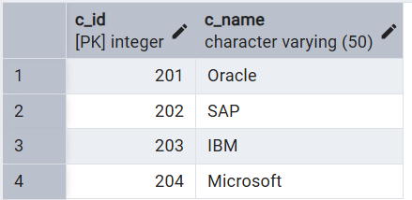
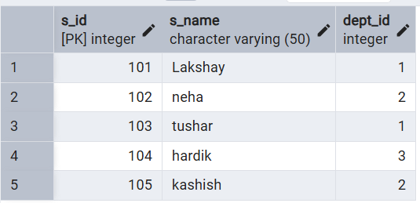
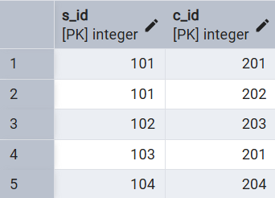

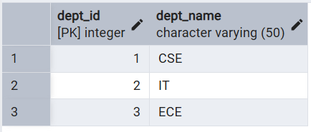

Step 1: Write queries to list students with their enrolled courses (INNER JOIN).

Code:

SELECT s.s_id, s.s_name, c.c_name

FROM student s

INNER JOIN enrollment e ON s.s_id = e.s_id

INNER JOIN course c ON e.c_id = c.c_id;

Output:

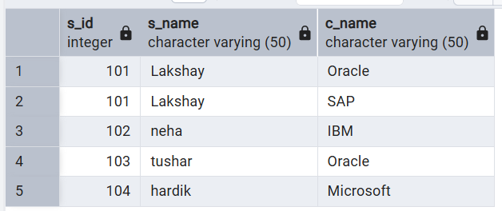

Step 2Find students not enrolled in any course (LEFT JOIN).

Code:

SELECT s.s_id, s.s_name

FROM student s

LEFT JOIN enrollment e ON s.s_id = e.s_id

WHERE e.c_id IS NULL;

Output:

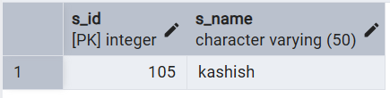

Step 3: Display all courses with or without enrolled students (RIGHT JOIN).

Code:

SELECT s.s_name, c.c_name

FROM enrollment e

RIGHT JOIN course c ON e.c_id = c.c_id

LEFT JOIN student s ON e.s_id = s.s_id;

Output:

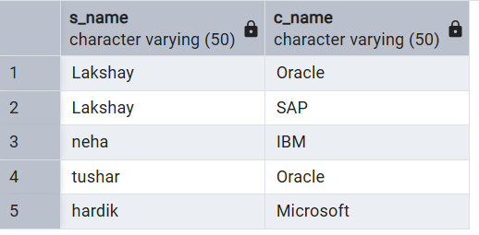

Step4: Show students with department info using SELF JOIN or multiple joins.

CODE:

SELECT s.s_id, s.s_name, d.dept_name

FROM student s

INNER JOIN department d ON s.dept_id = d.dept_id;

OUPUT:

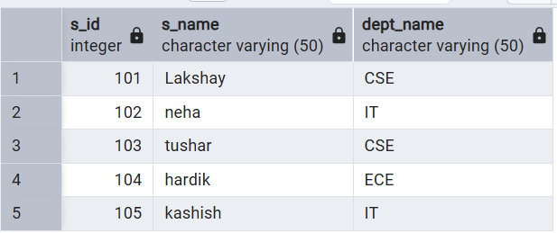

STEP5: Display all possible student-course combinations (CROSS JOIN). (Oracle, SAP, IBM, Microsoft)

CODE:

SELECT s.s_name, c.c_name

FROM student s

CROSS JOIN course c;

SELECT s.s_name, c.c_name

FROM student s

CROSS JOIN course c;

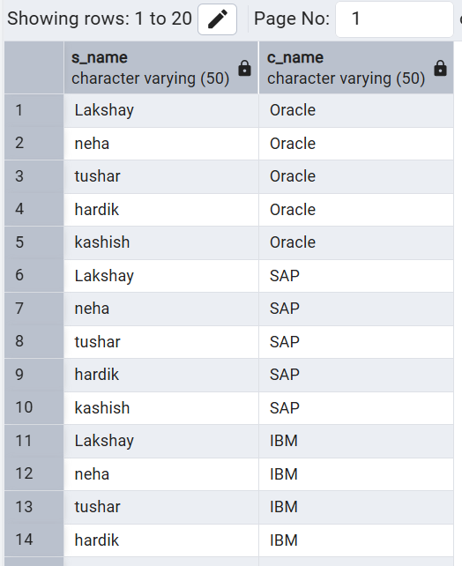
OUTPUT:

- Learning Outcomes (What I have learned):
- Join Understanding: I learned how to use different types of SQL joins to retrieve related data from multiple tables.
- Practical Database Skills: I understood how real-world schemas such as Students, Courses, Enrollments, and Departments are related in a relational database.
- Data Analysis Ability: I learned how to identify matching and non-matching records using INNER JOIN, LEFT JOIN, and RIGHT JOIN.
- Advanced SQL Usage: I understood the use of SELF JOIN for hierarchical relationships and CROSS JOIN for generating all possible combinations.
- PostgreSQL Practice: I gained hands-on experience in writing and executing SQL queries in PostgreSQL / pgAdmin.

